**Lab report no 6**



**Fall 2022**

# Control System Lab

**Submitted By**

**Name Registration No**

# Muhammad Ali 19pwcse1801

Section: **A**

**Date**: 15,11,22

**Submitted to: Dr Muniba Ashfaq**

Department of Computer Systems Engineering

University of Engineering and Technology, Peshawar

**Objectives: -**

* To understand differentiation of the system in Simulink.
* To learn how to find simulation of differential equation with initial condition.

**Task no 1: -**

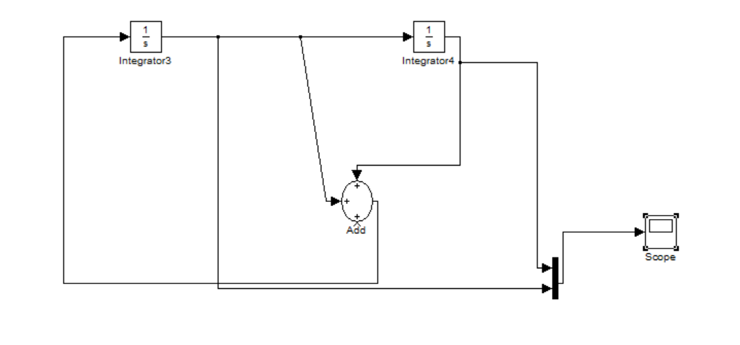

**Plot: -**

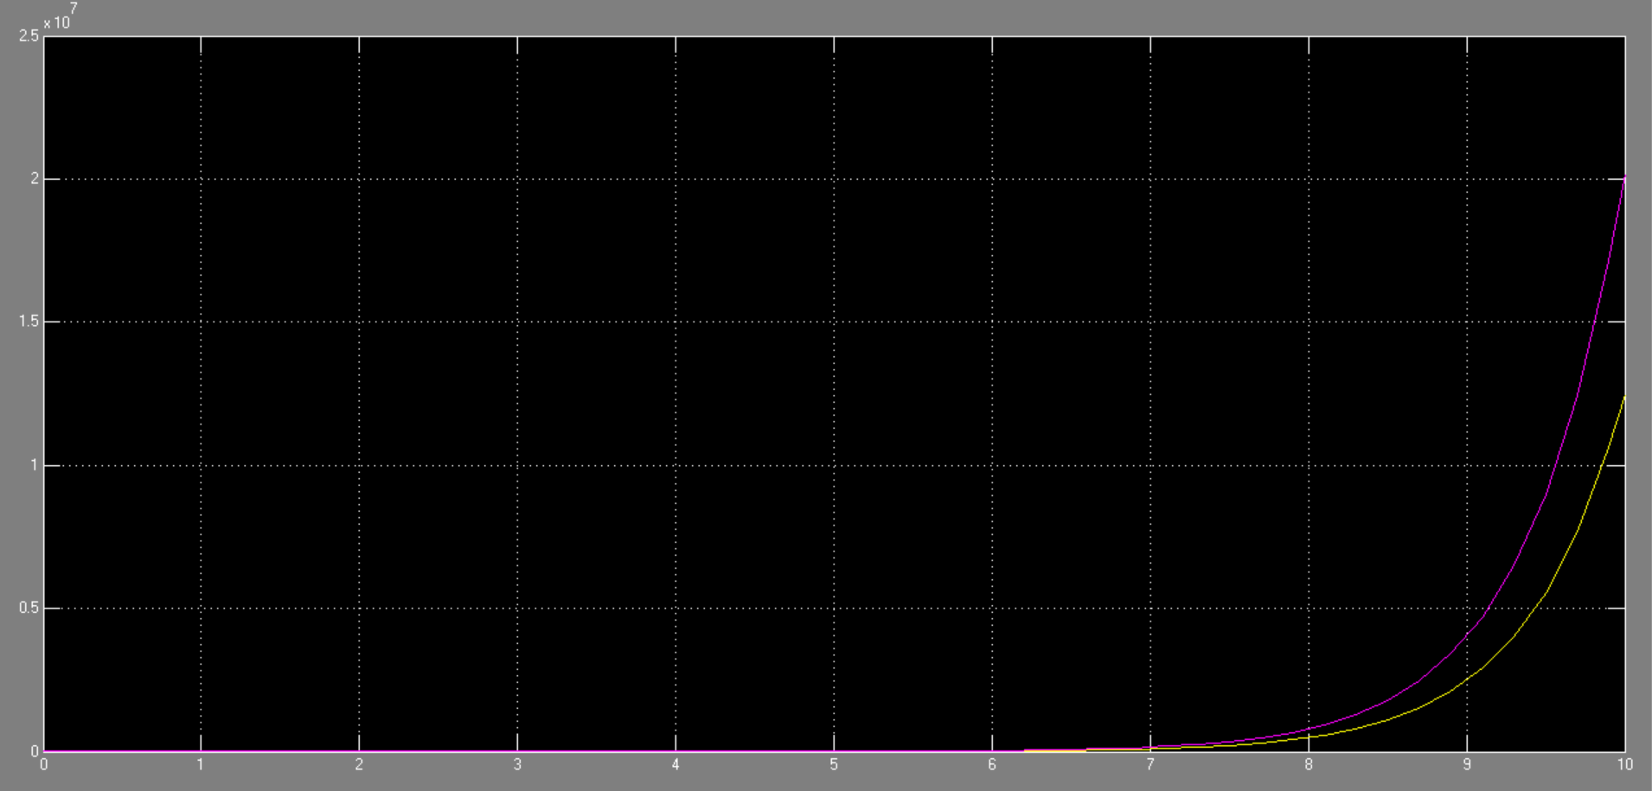

**Task no 2: -**

Shematic for the derivative exression of

y`````+ 48y````+ 24y``` +21y`` +20y` +10 = 0

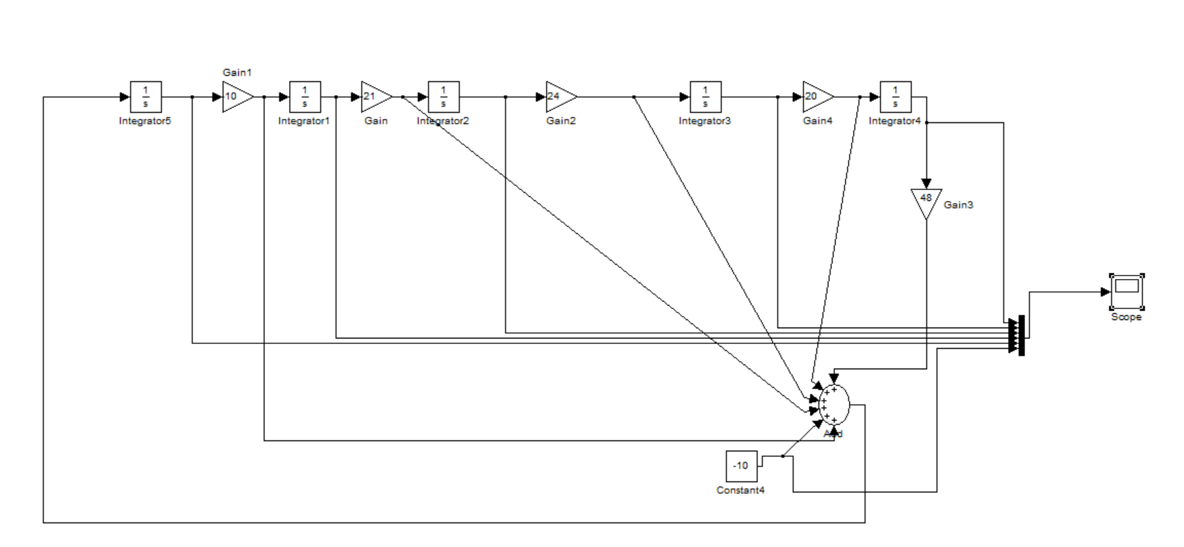

**Plot: -**

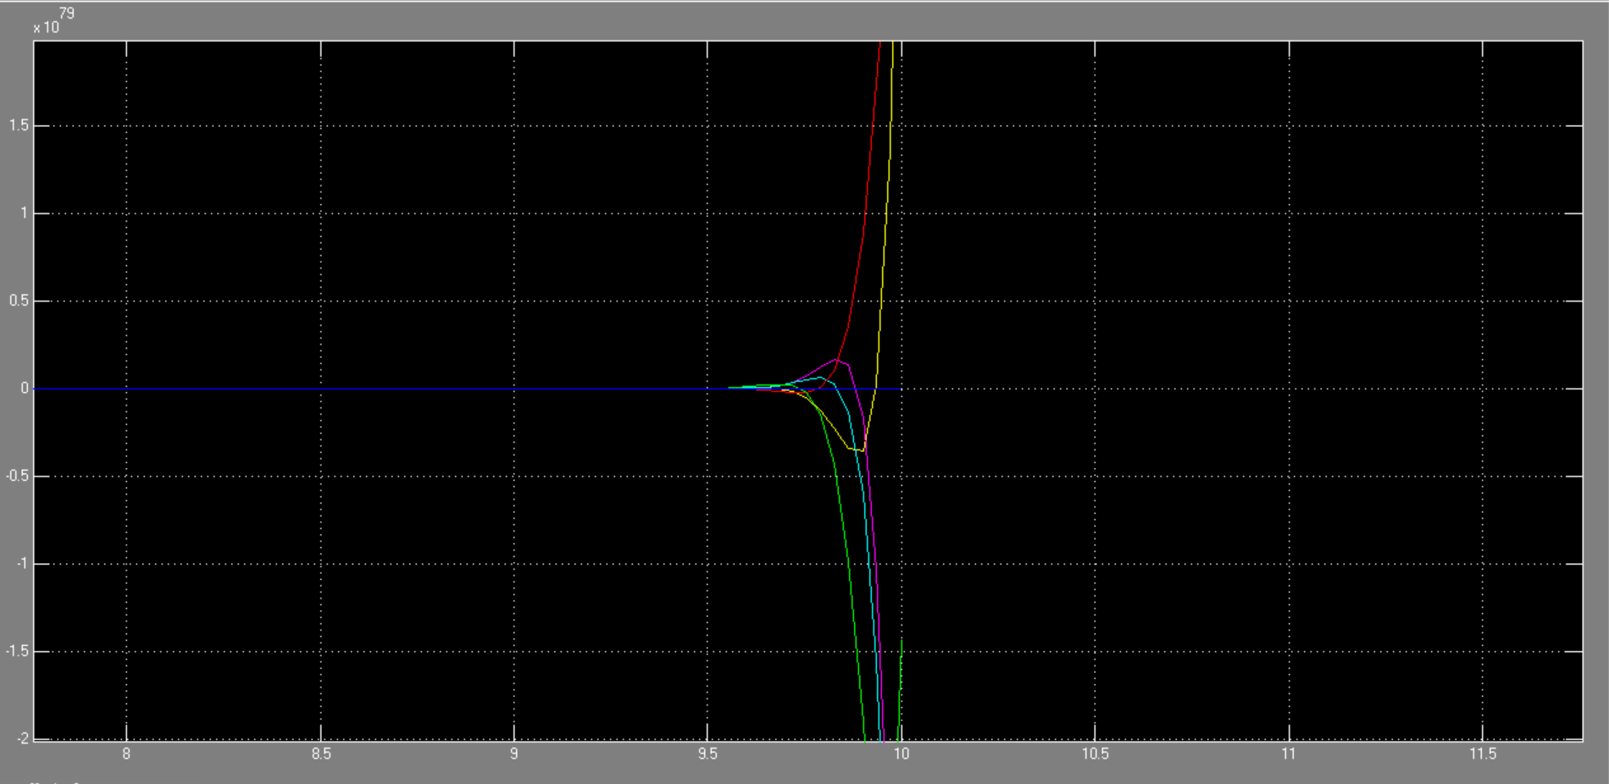

**Task no 3: - (equation by example)**

**Simulink: -**

Shematic for the derivative exression of

y````+ 24y``` +21y`` +10y` + 5 = 0

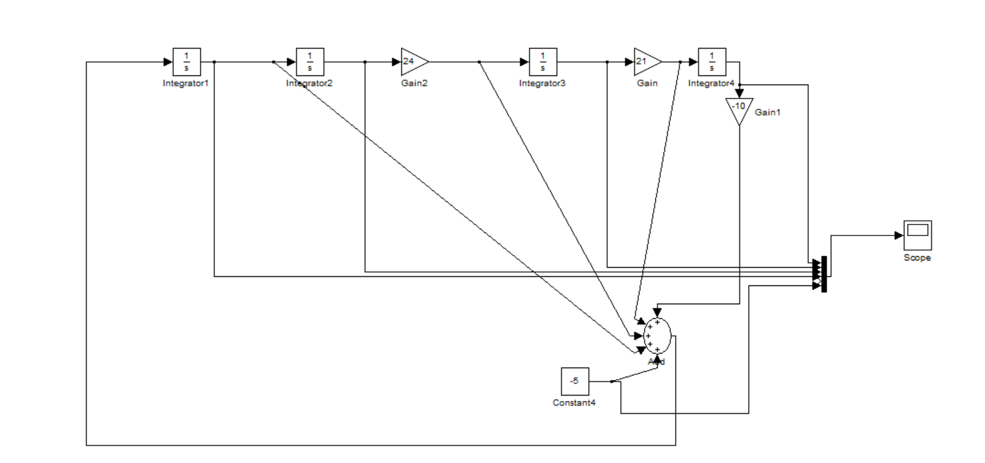

**Plot: -**

